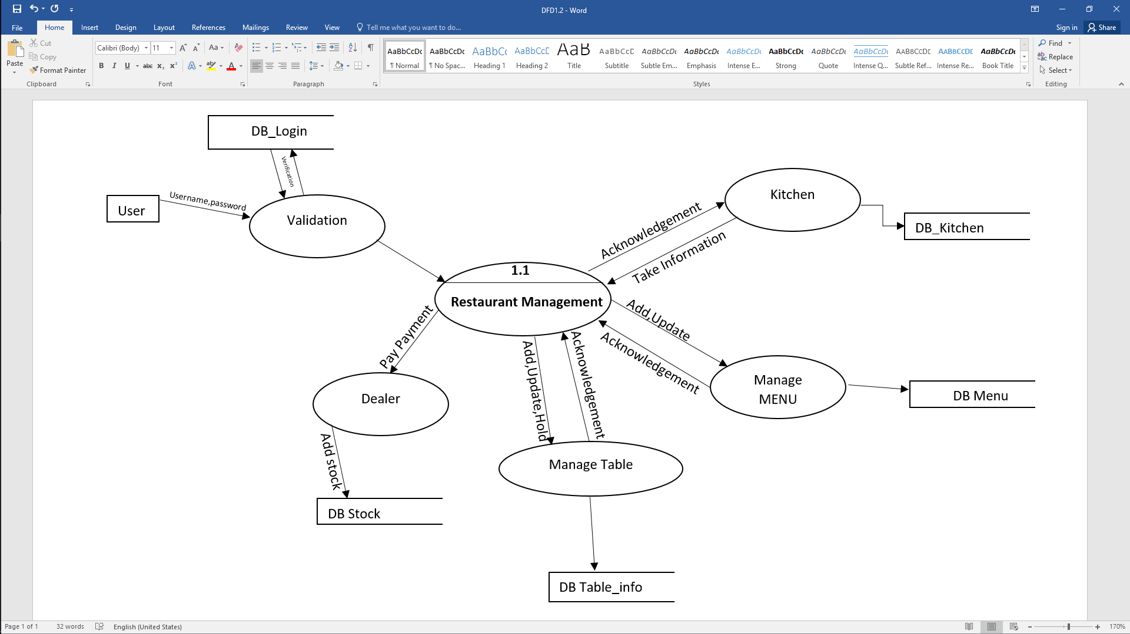

**Customer**

Take Requirement

**Receptionist**

Ask Requirement

**1.0**

Provide Information

**Reservation**

Discuss Requirement

**Vator**

Take Requirement

Provide Service

Receive Information

Discuss Requirement

Pay Bill

**Manager**

Provide Service

Receive Payment

Give Payment

**Payment Details**

**Order Details**

**Customer Details**

**1.4**

**1.3**

**1.2**

**1.1**